Image result for blank facebook profile picture

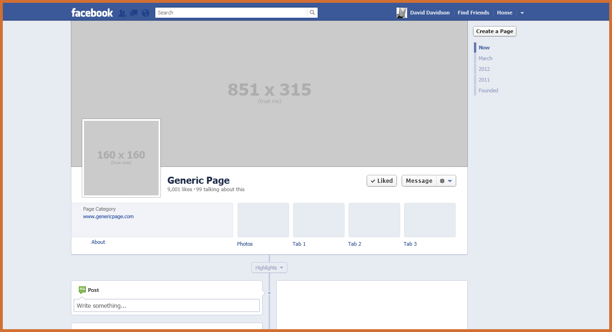

**Sam**

**Find Friends**

**Home**

**Samantha**

Works at:

Staff at the UNIVERSITY OF GLOUCESTERSHIRE

Hobbies:

Zumba and Music

Samantha

February 26th at 15:48 PM

Managed to finish early at work today! Time to get some sun in the garden before heading off to Zumba at 7pm. Always the highlight of my week and great to catch up with the gang too!

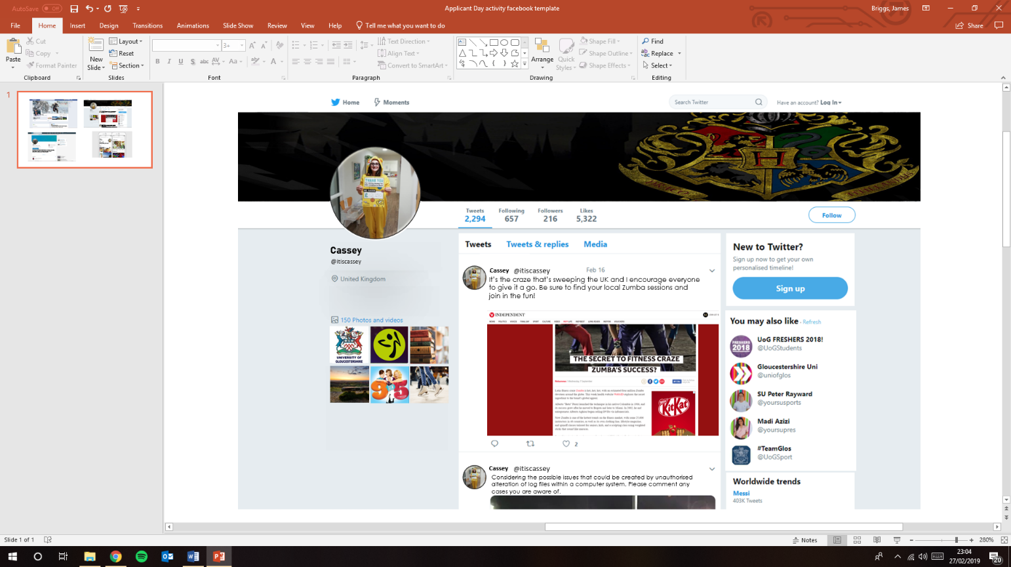

Send

Attach

To:

Subject:

From:



Image result for blank facebook profile picture

**Samantha**

**Samantha** @sammy1

**Samantha** @sammy1

**Samantha**

